**Core Beliefs**

Everyone looks at the world differently. Two people can have the same experience, yet have very different interpretations of what happened.

**Core beliefs** are the deeply held beliefs that influence how we interpret our experiences.

Think of core beliefs like a pair of sunglasses. Everyone has a different “shade” that causes them to see things differently.

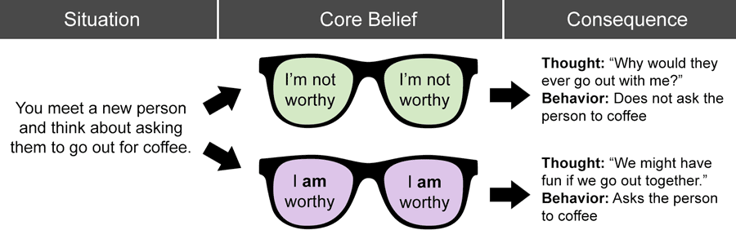

Many people have negative core beliefs that cause harmful consequences. To begin challenging your negative core beliefs, you first need to identify what they are. Here are some common examples:

|  |  |  |
| --- | --- | --- |
| I’m unlovable | I’m stupid | I’m boring |
| I’m not good enough | I’m ugly | I’m worthless |
| I’m a bad person | I’m abnormal | I’m undeserving |

What is one of your negative core beliefs? List three pieces of evidence contrary to your negative core belief.

1.

2.

3.

